Use this document if you are downloading the installer.

1. Go to the following URL
2. <https://www.python.org/downloads/release/python-378/>

and download the following file; Windows X86-64 Executable Installer

1. Double-click on python-3.7.8-amd64.exe file.

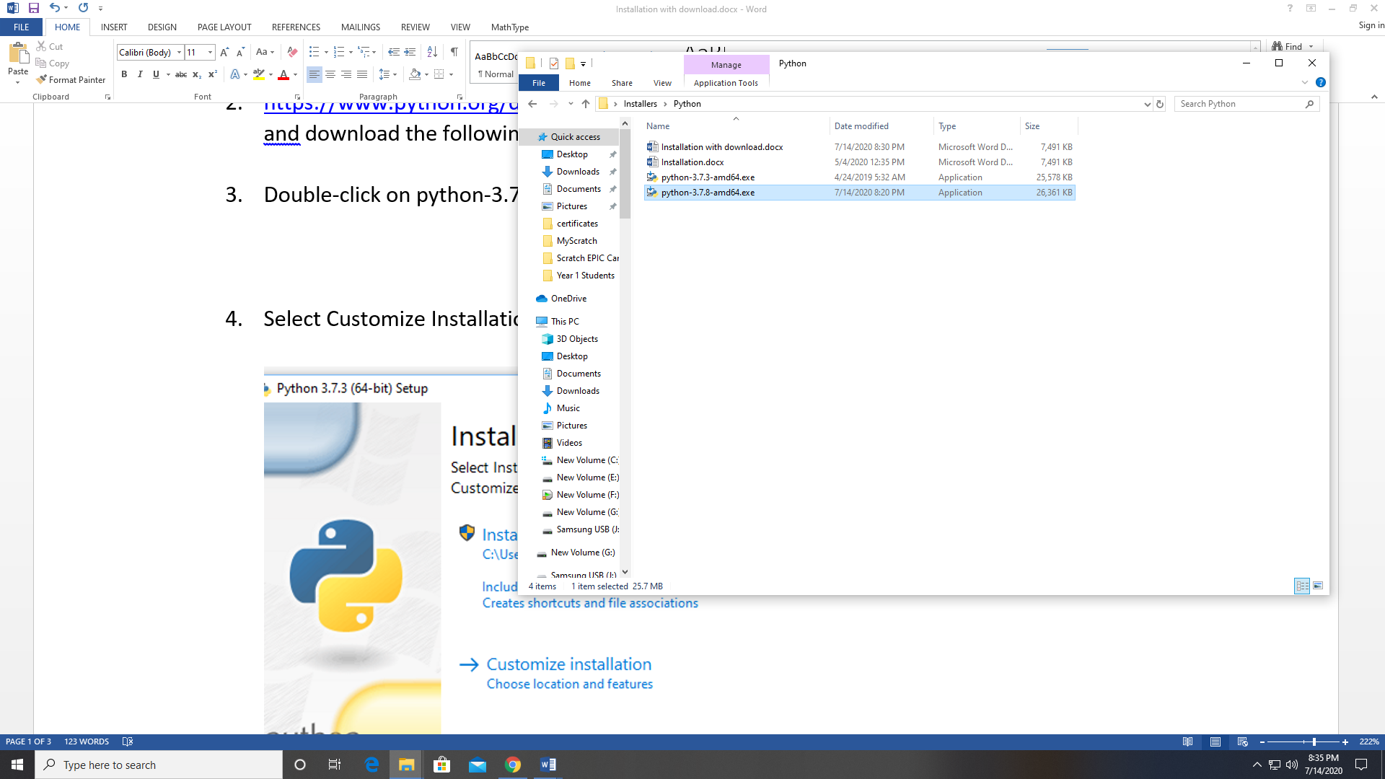

1. Select Customize Installation and make sure Add Python 3.7 to PATH is checked.

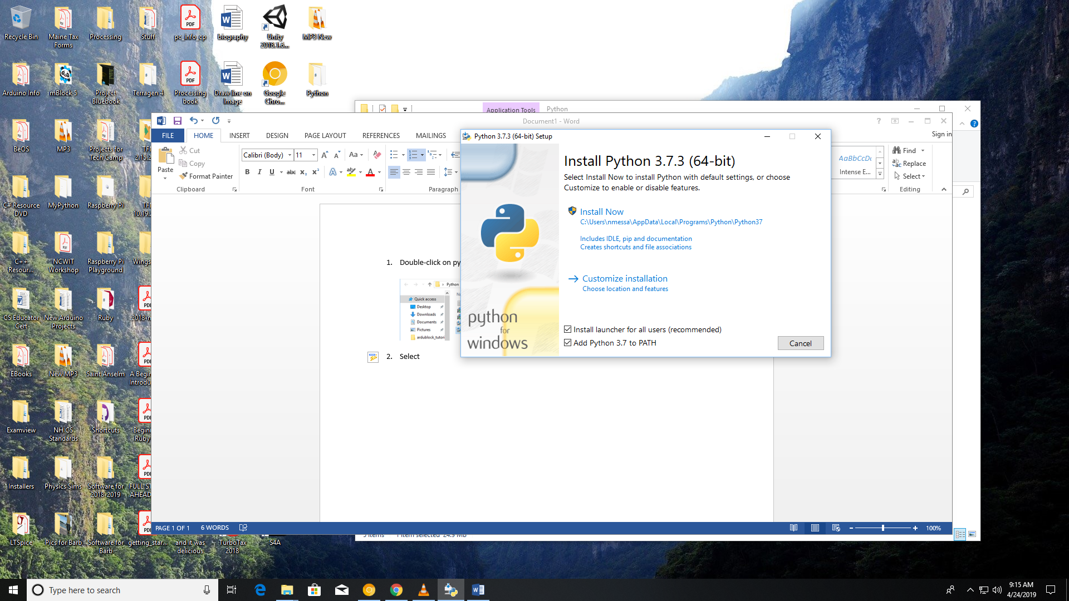

1. Select all options and click Next

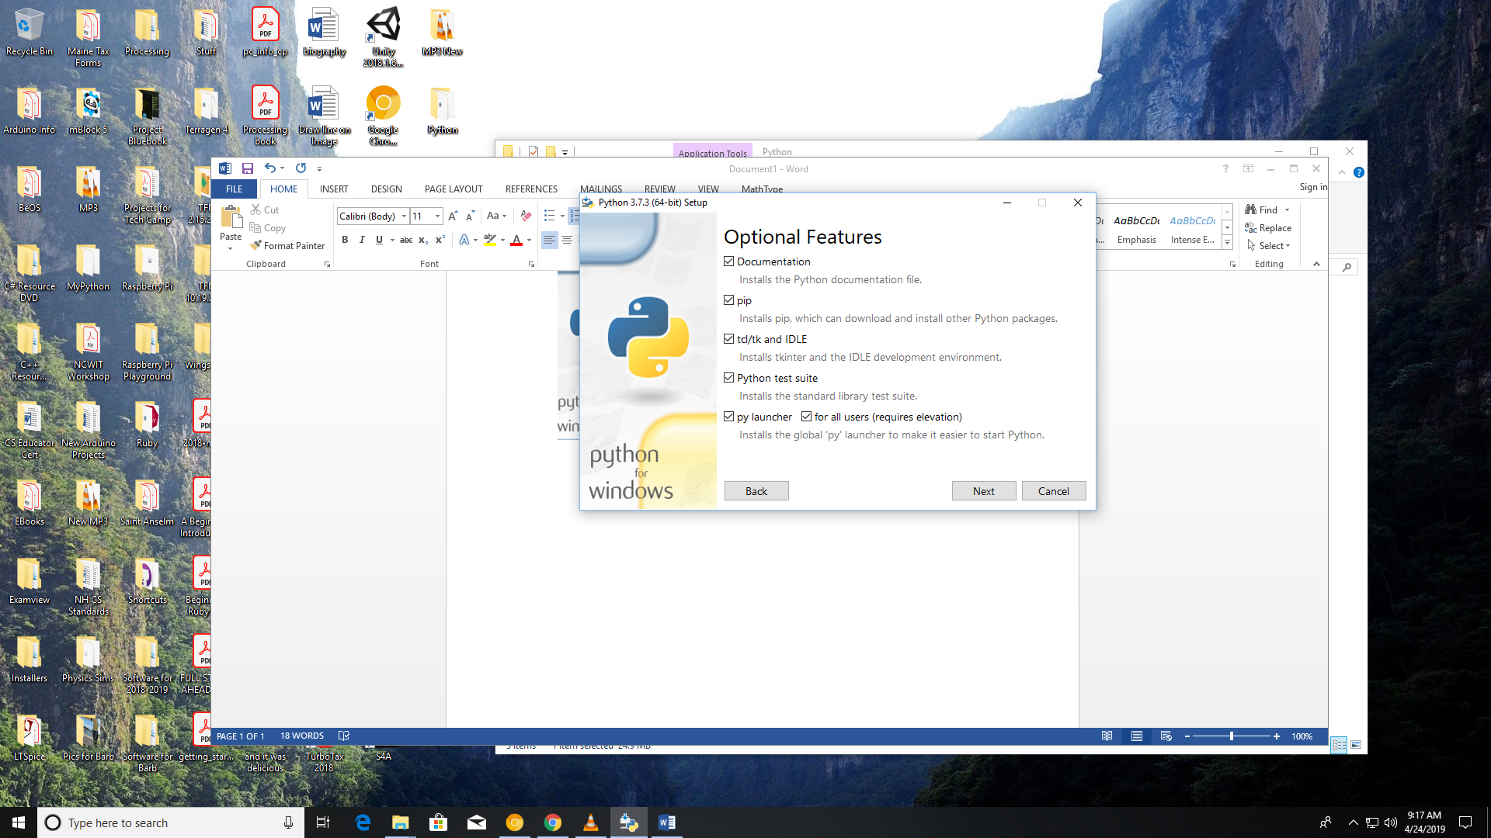

1. Select Install for all users and click on Install.

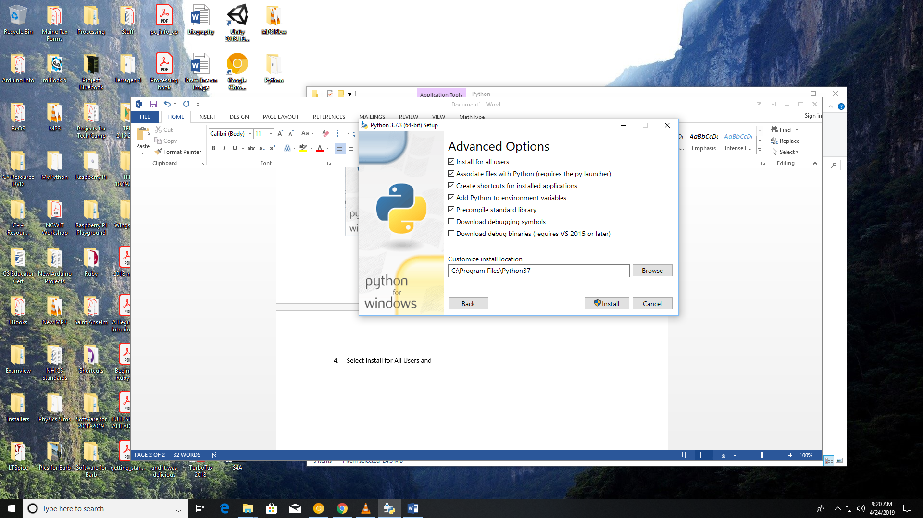

1. When installation is complete you should get this message.

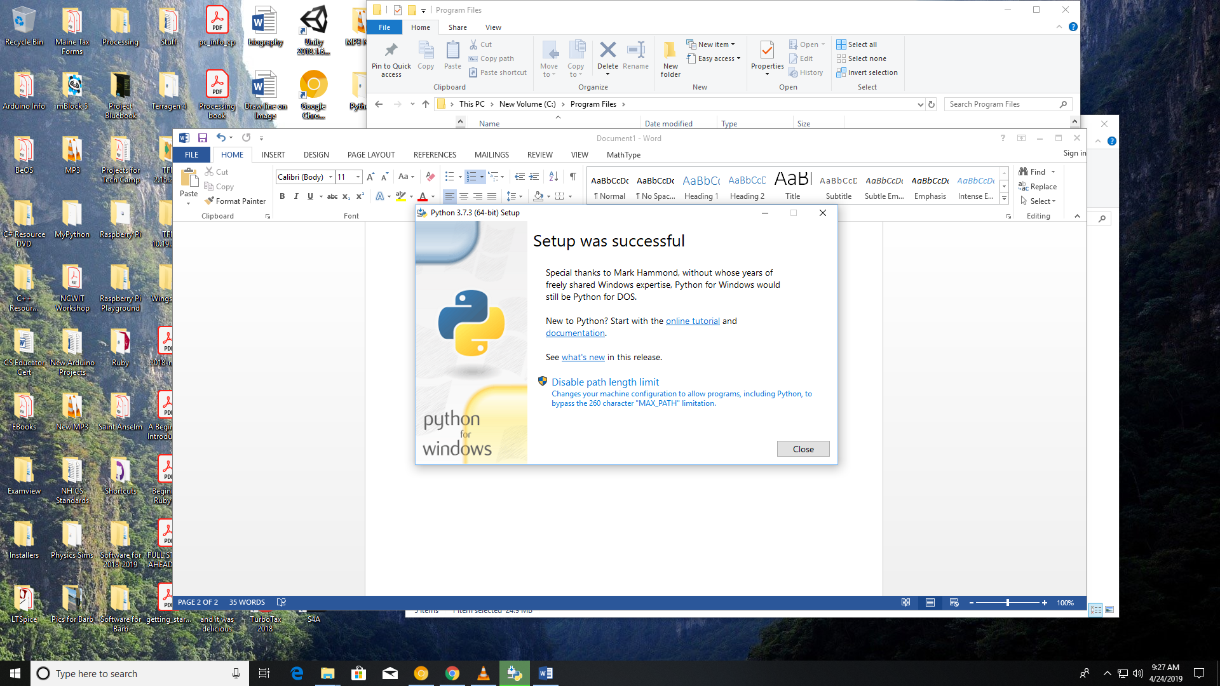

To install other Python Packages you will have to run the command shell as administrator.

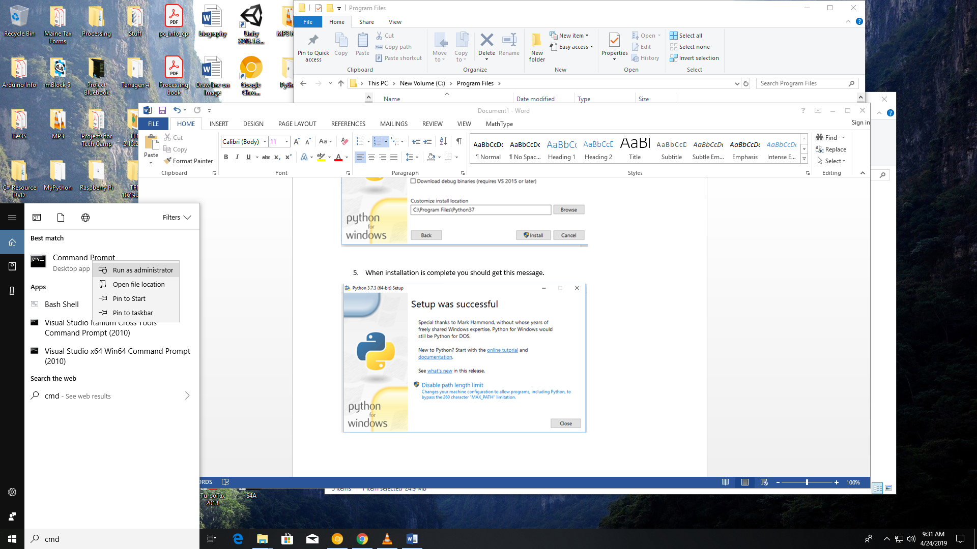

Execute the following commands:

pip install pygame

pip install numpy

pip install matplotlib

pip install scipy

pip install arcade

pip install guizero

pip install pyserial

pip install vpython

pip install pgzero

To test your installation, start the Python Shell and attempt to import these modules.

